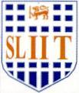
Image Understanding and Processing (OpenCv - Python)

Practical Examination – E
Year 4 Semester 1, 2021

Apply a suitable noise filter to the input image (A) and obtain the output image (B). Then apply Unsharp Masking to generate the output (C) with use of the given filter below. Use the below code to generate the output images.

1 | 1 | 1 | 1 | 1
1 | 1 | 1 | 1 | 1
1 | 1 | 1 | 1 | 1
1 | 1 | 1 | 1 | 1
1 | 1 | 1 | 1 | 1

1/25

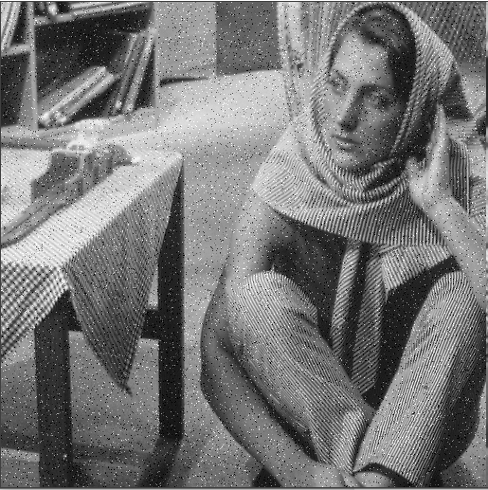
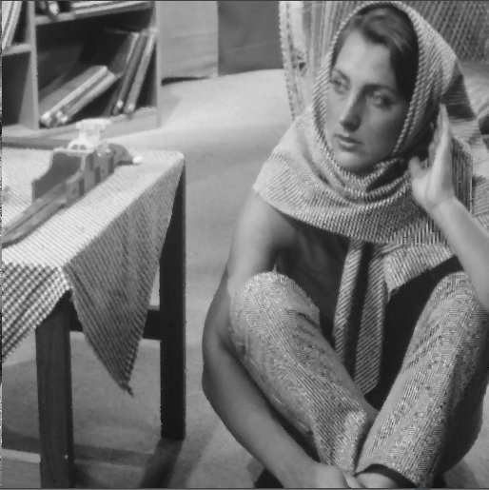
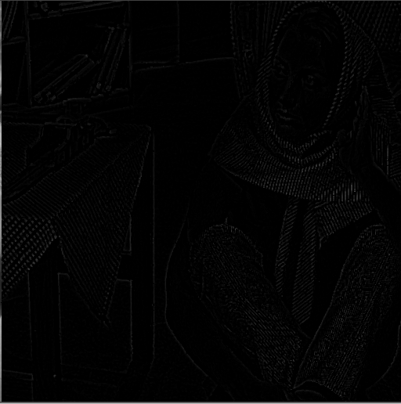

Input Image (A)
Output Image (B)
Output Image (C)
